Task 1: Create a database named *employee*, then import **data_science_team.csv proj_table.csv** and **emp_record_table.csv** into the **employee** database from the given resources.

1.Create a database employee

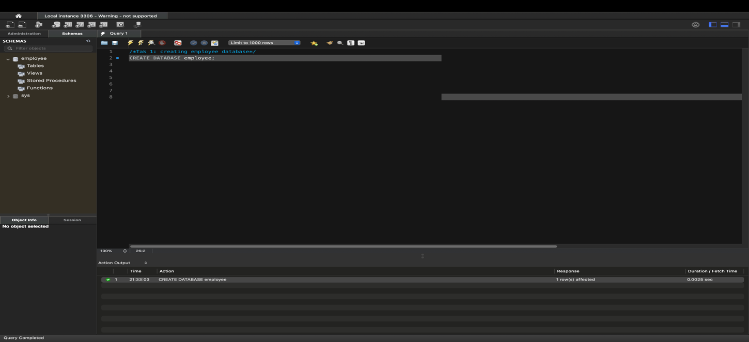

2. Use employee for default schema

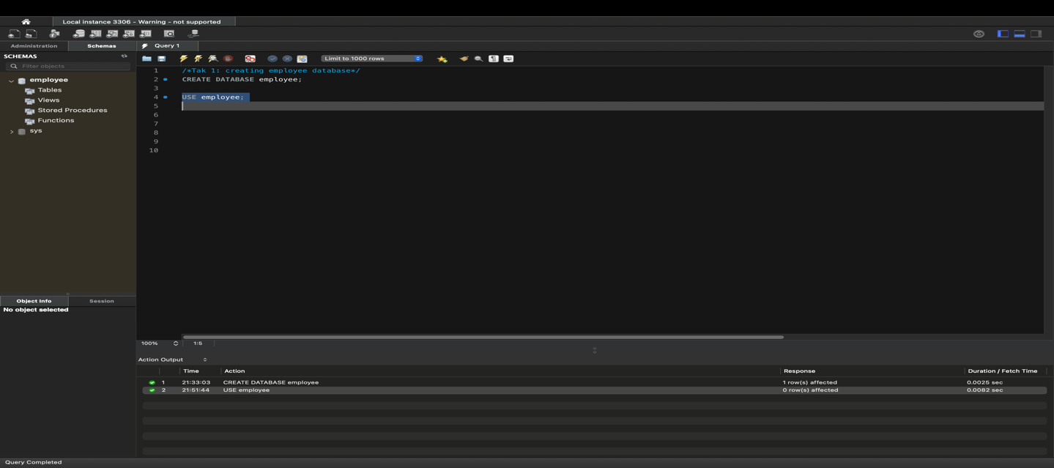

Or manually set employee as default schema.

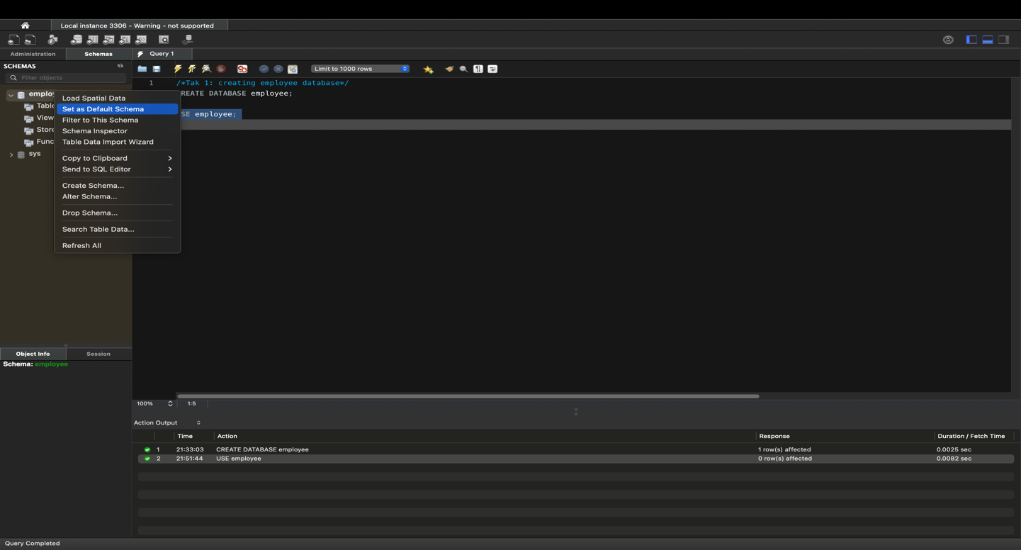

Now again , Right click on employee schema and click on Table Data Import Wizard.

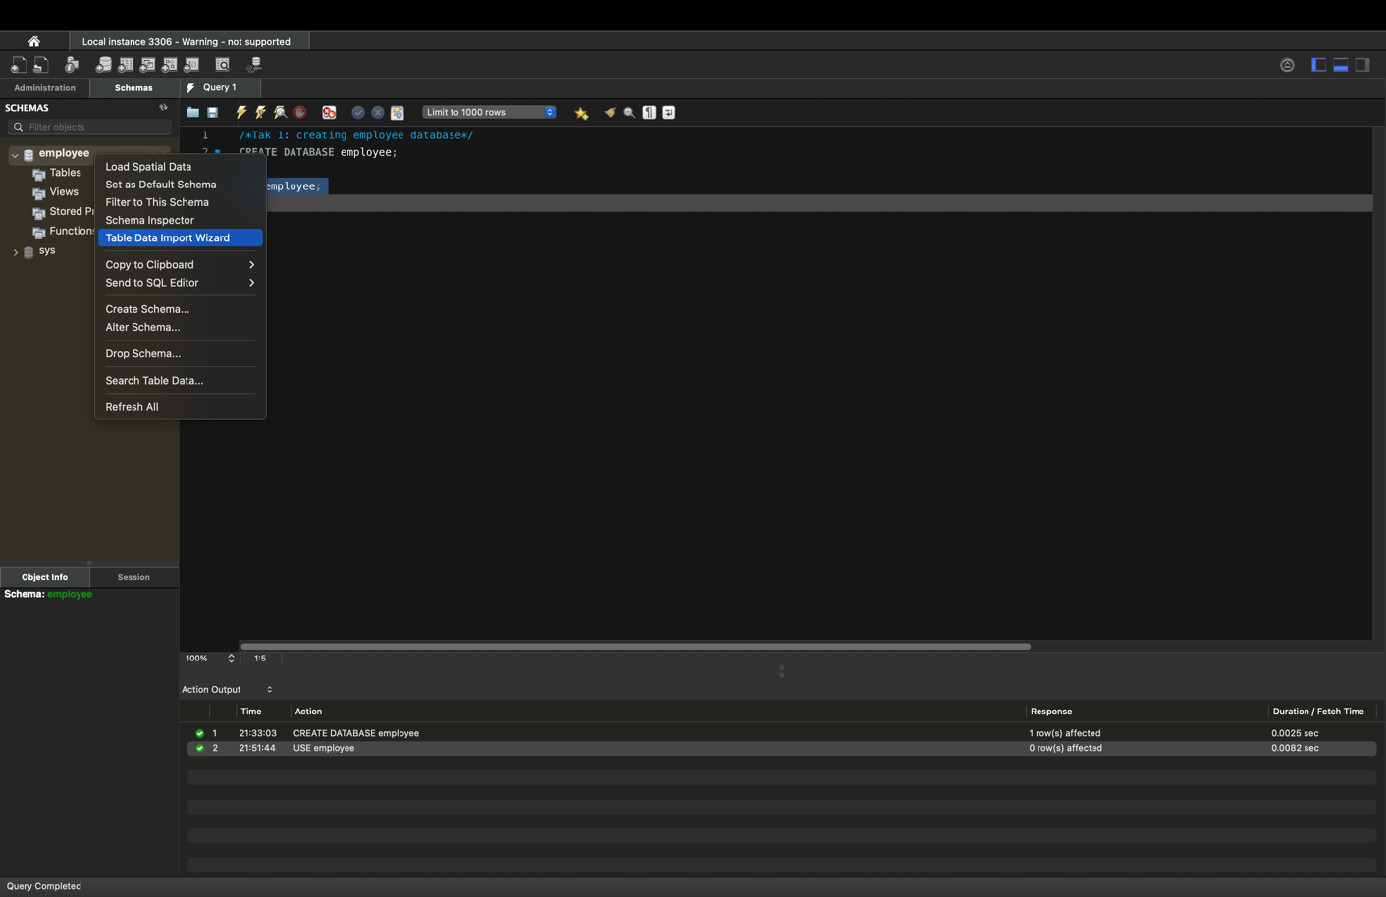

Now, import Data_Science_Team table from the given Data Set.

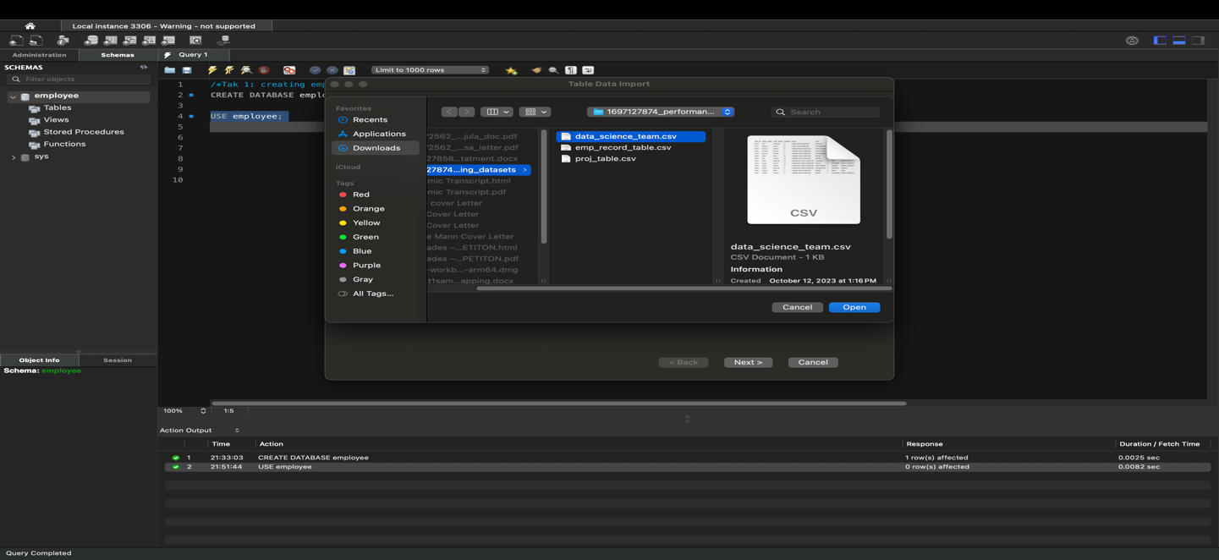

Select Destination

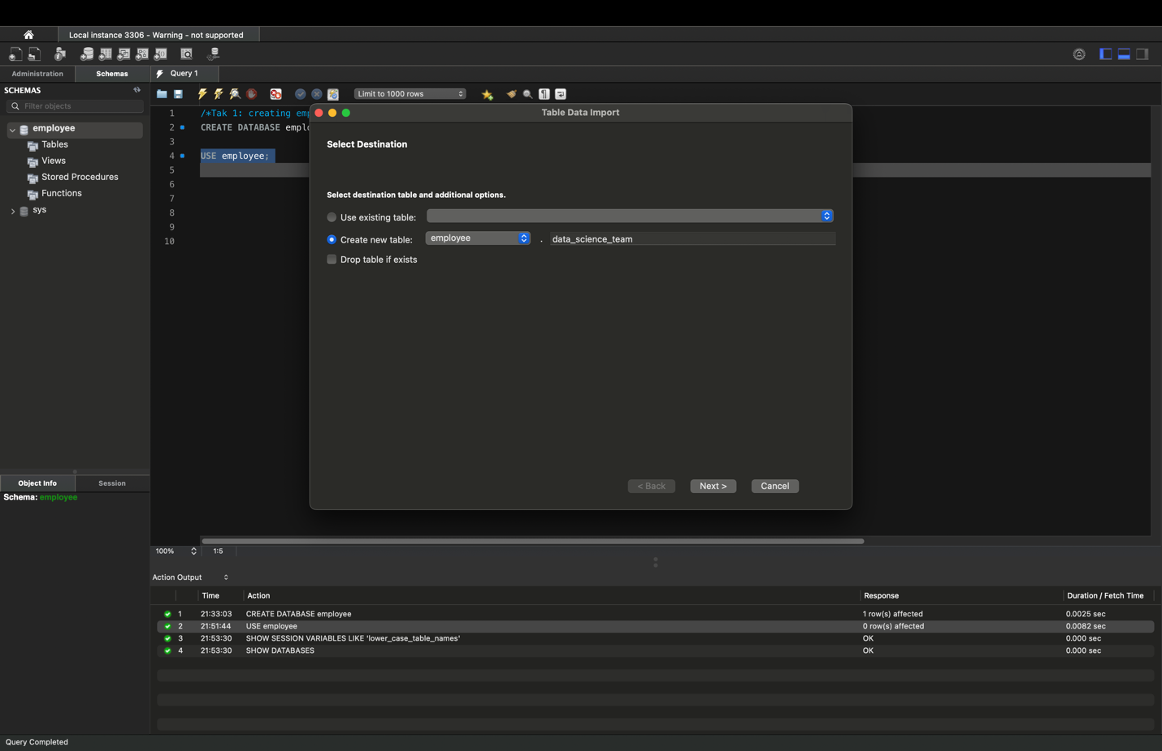

Configure import settings and click on next.

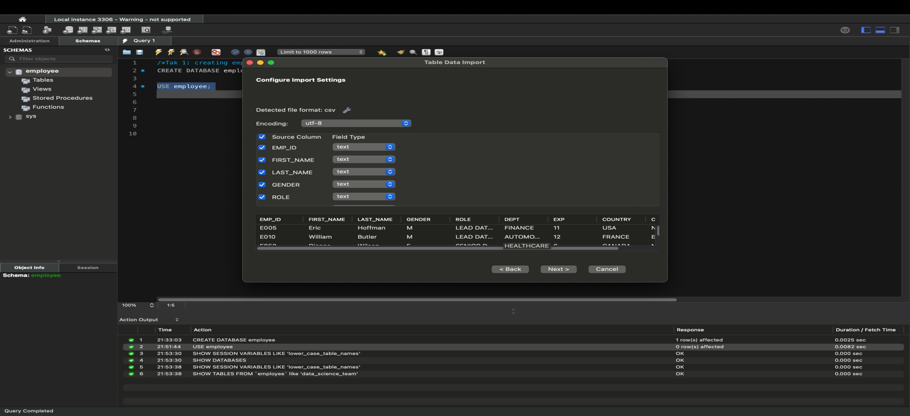

Click on next to import data

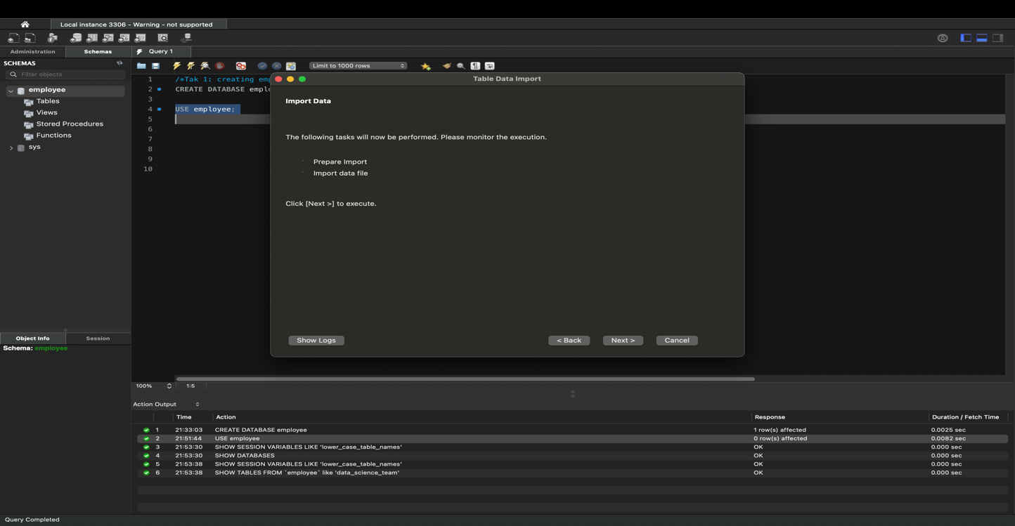

Table employee.data_science_team was created, 13 records imported and click on Finish.

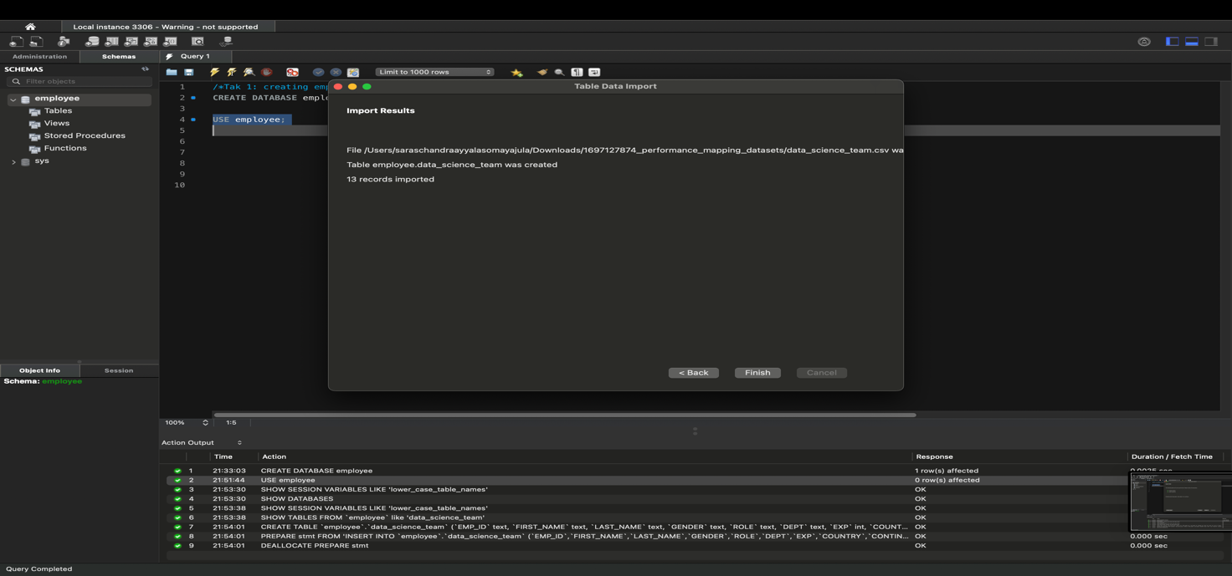

Under Schema, click on refresh button to view Data science team in Tables column.

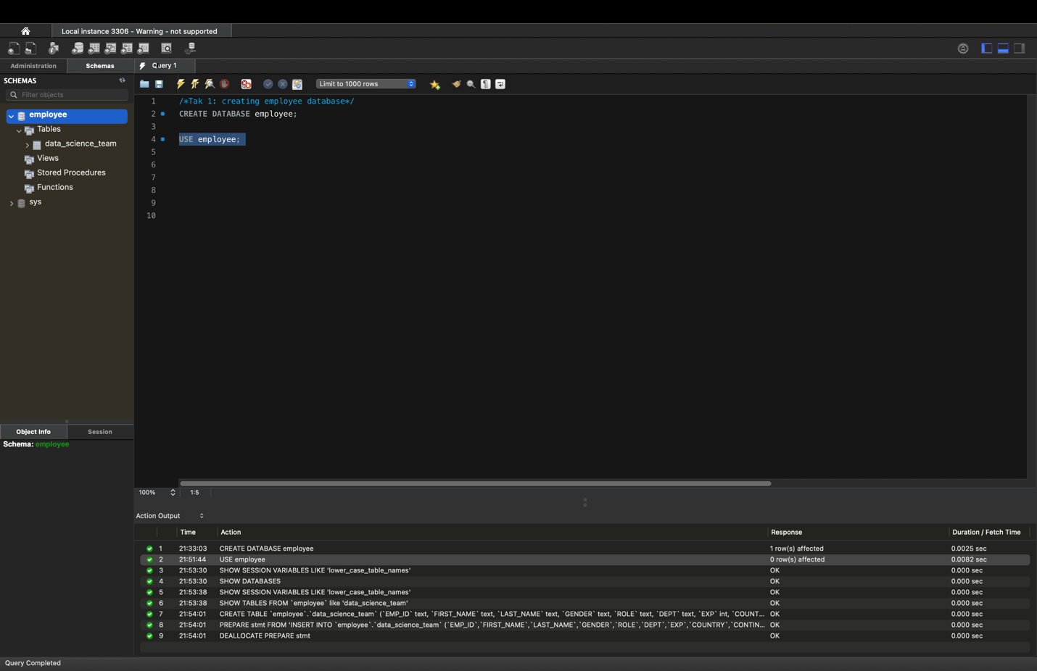

Similarly, repeat the steps to import emp_record _table.

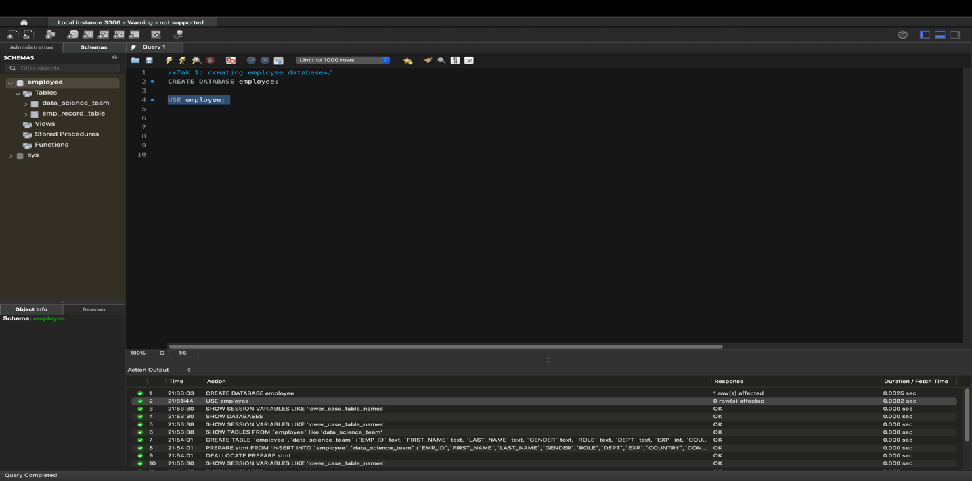

Also, repeat the steps to import proj _table.

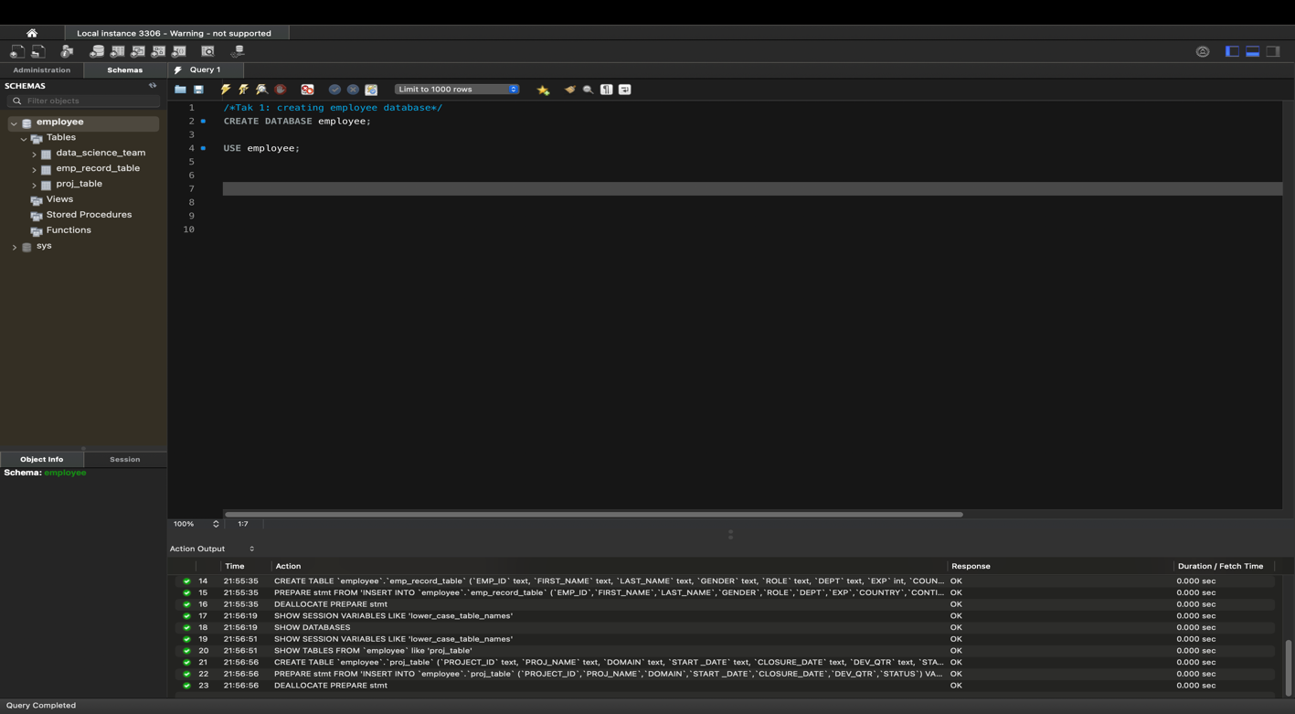

**Task 2:** Create an ER diagram for the given **employee** database.

-Click on Reverse Engineer under Database tab.

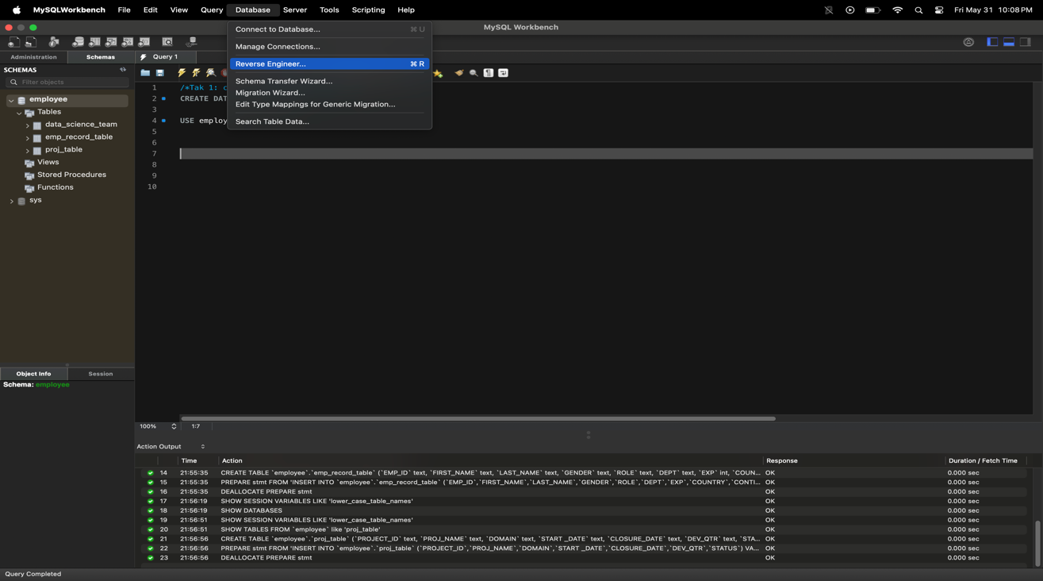

Enter the root Password:

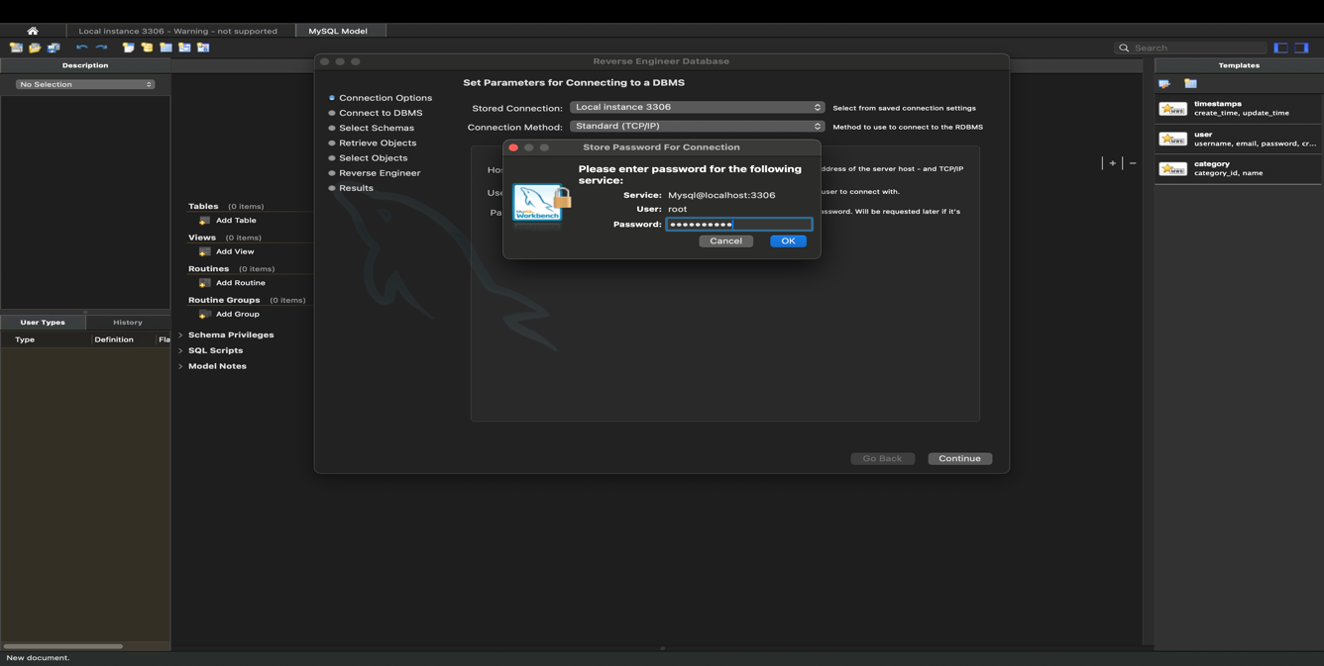

Click on Continue till the end of the process.

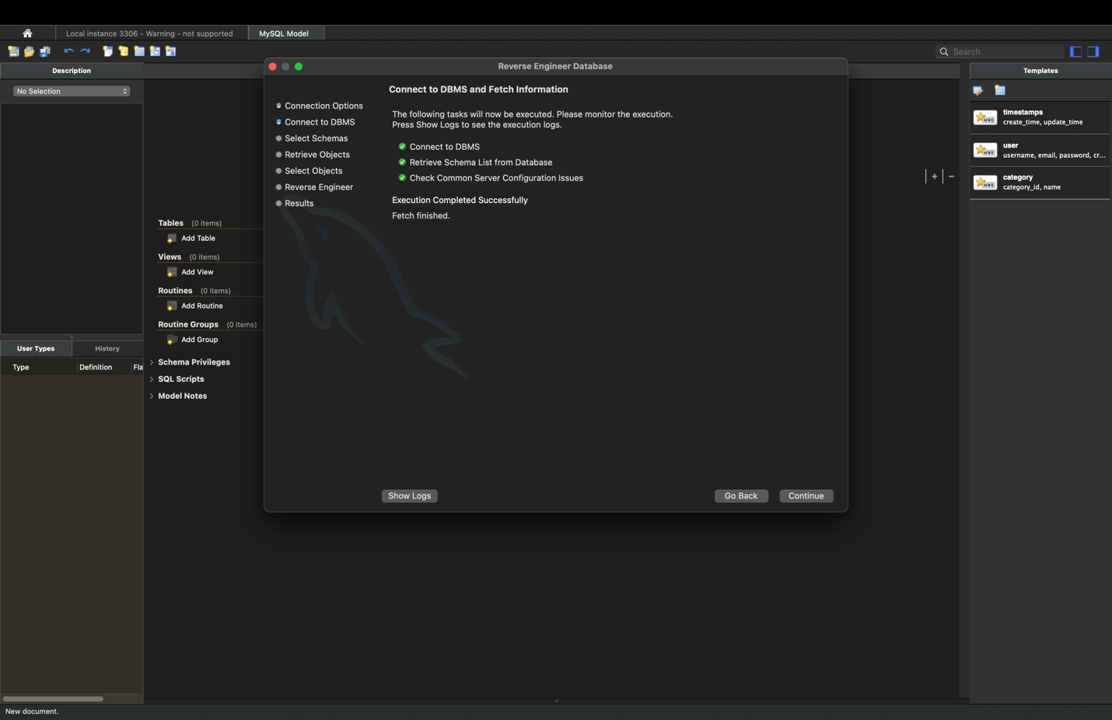

Result :

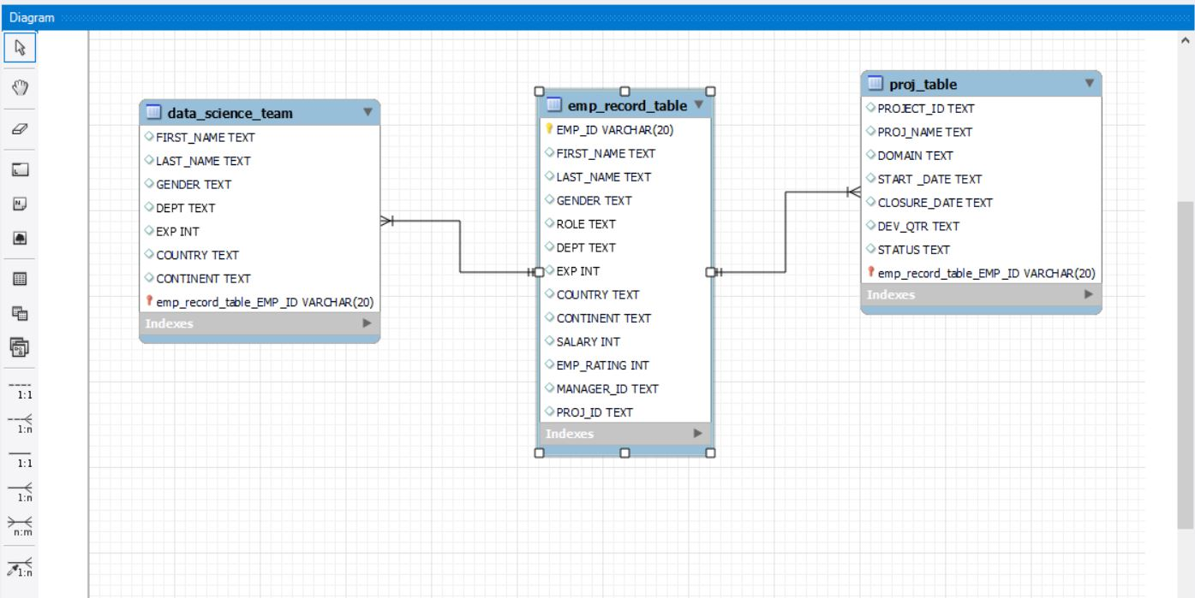

Task 3: Write a query to fetch EMP_ID, FIRST_NAME, LAST_NAME, GENDER, and DEPARTMENT from the employee record table, andmake a list of employees and details of their department.

Code:

/*Task 3: List of employees and details of their department*/

SELECT emp_id, first_name, last_name, gender, dept

FROM emp_record_table

ORDER BY dept;

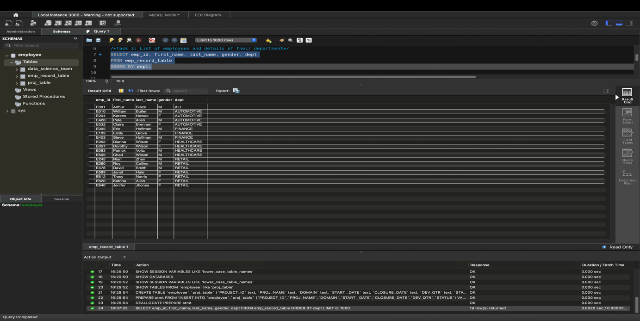

**Task 4:** Write a query to fetch EMP_ID, FIRST_NAME, LAST_NAME, GENDER, DEPARTMENT, and EMP_RATING if the EMP_RATING is:

1)less than two

Code:

-- Task 4:List of employees and their details of their department

-- emp rating <2

SELECT emp_id, first_name, last_name, gender, dept, emp_rating

FROM emp_record_table

WHERE emp_rating<2;

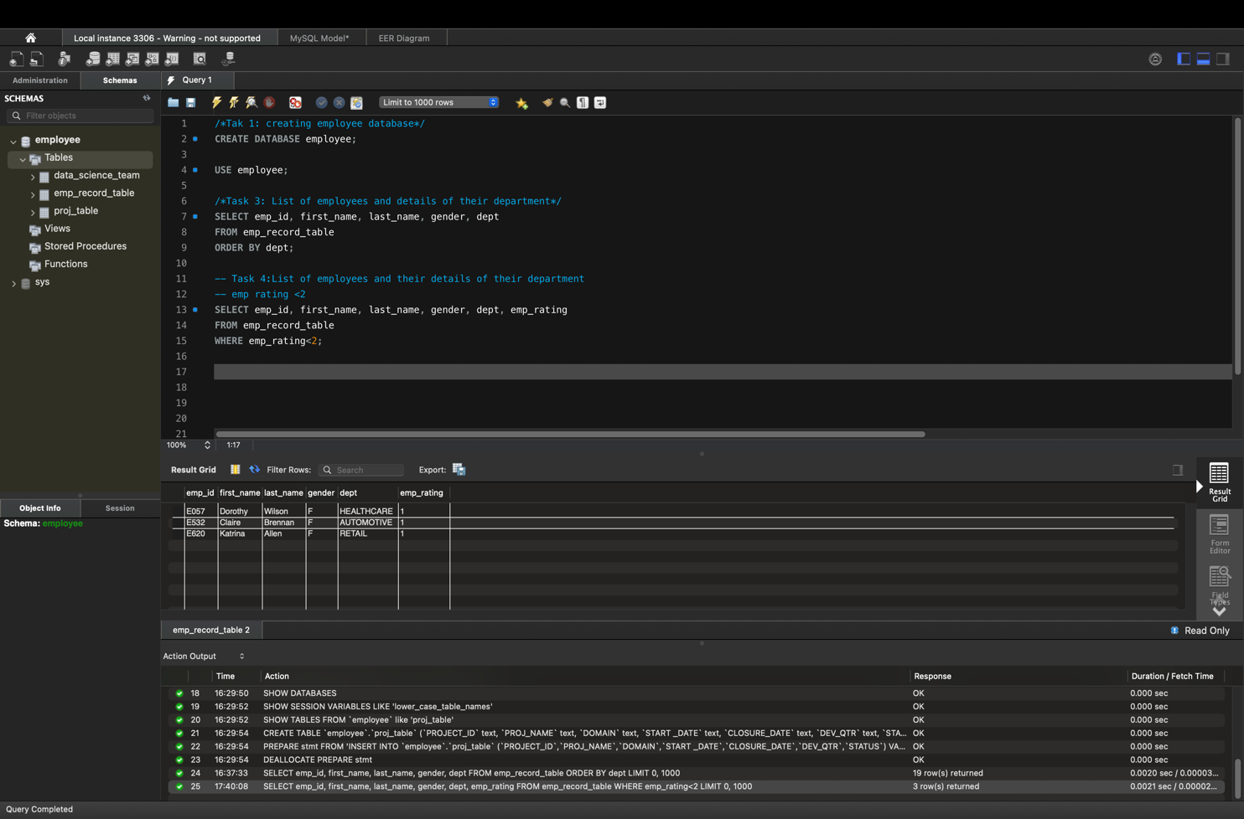

2) greater than four

Code:

-- emp rating >4

SELECT emp_id, first_name, last_name, gender, dept, emp_rating

FROM emp_record_table

WHERE emp_rating>4;

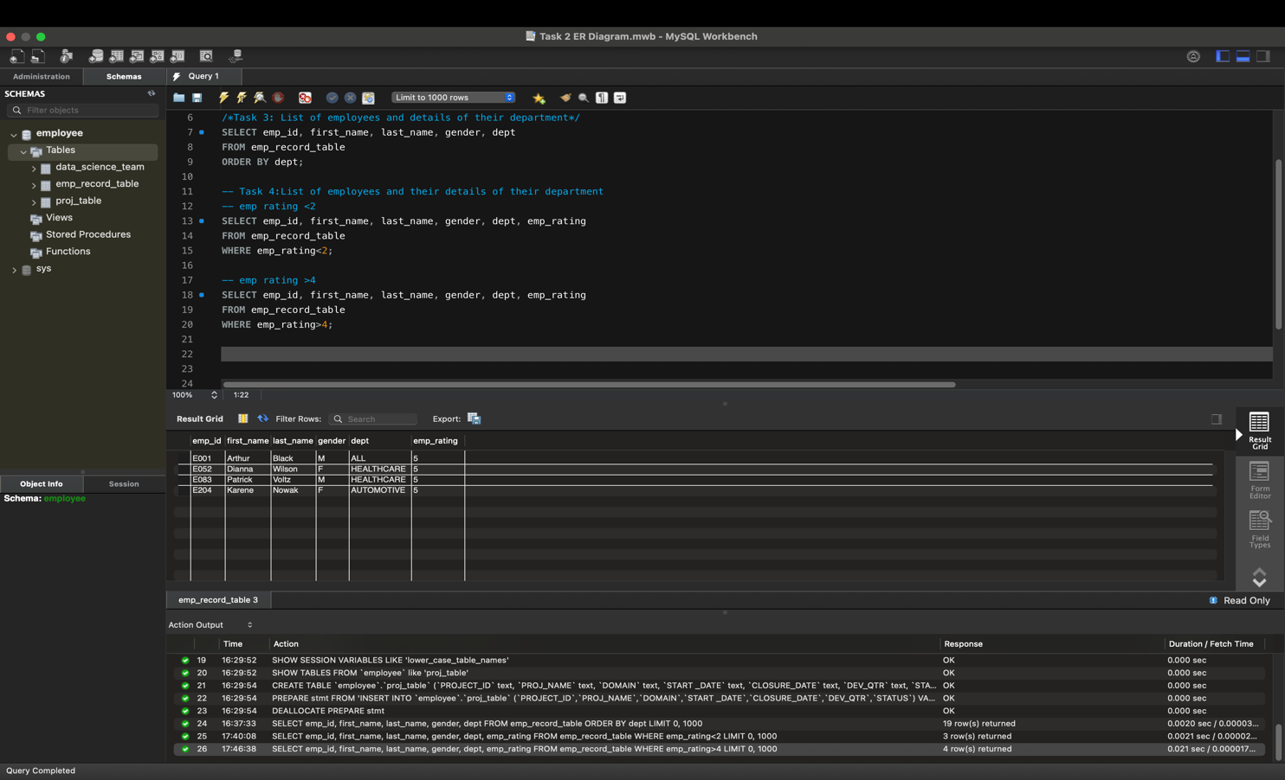

3) between two and four

Code:

-- emp rating between 2 and 4

SELECT emp_id, first_name, last_name, gender, dept, emp_rating

FROM emp_record_table

WHERE emp_rating BETWEEN 2 AND 4;

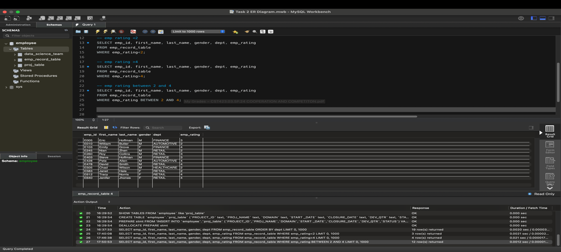

**Task 5**: Write a query to concatenate the FIRST_NAME and the LAST_NAME of employees in the *Finance* department from the employee table and then give the resultant column alias as NAME.

Code:

/* TASK 5: concatenate the FIRST_NAME and the LAST_NAME of employees in the Finance department from the employee table and then give the resultant column alias as NAME*/

SELECT CONCAT(first_name," ", last_name) AS name

FROM emp_record_table

WHERE dept = 'FINANCE';

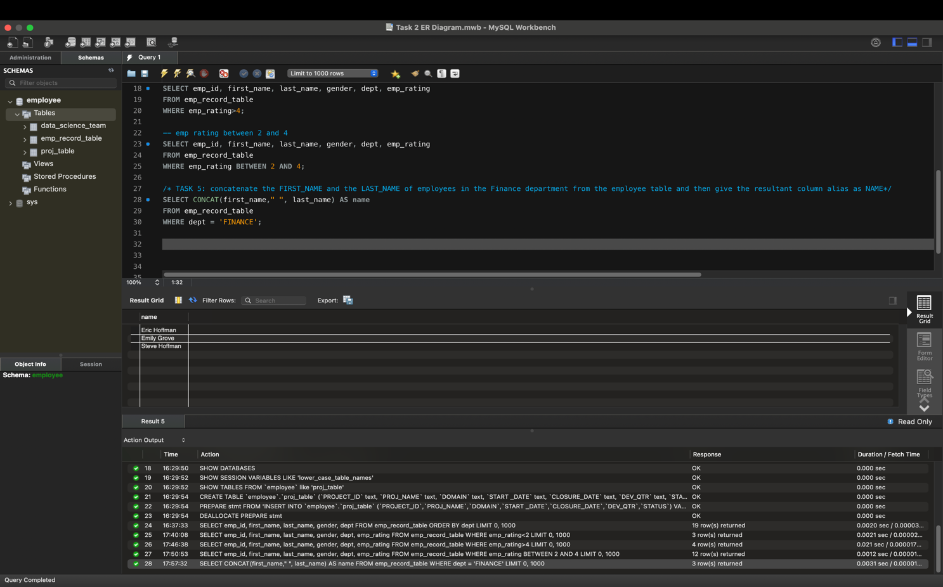

**Task 6**: Write a query to list only those employees who have someone reporting to them. Also, show the number of reporters (including the President).

Code:

-- TASK 6: to list only those employees who have someone reporting to them

SELECT m.emp_id, m.first_name MGR_NAME, COUNT(e.first_name) AS reportees

FROM emp_record_table e, emp_record_table m

WHERE e.manager_id = m.emp_id

GROUP BY m.emp_id;

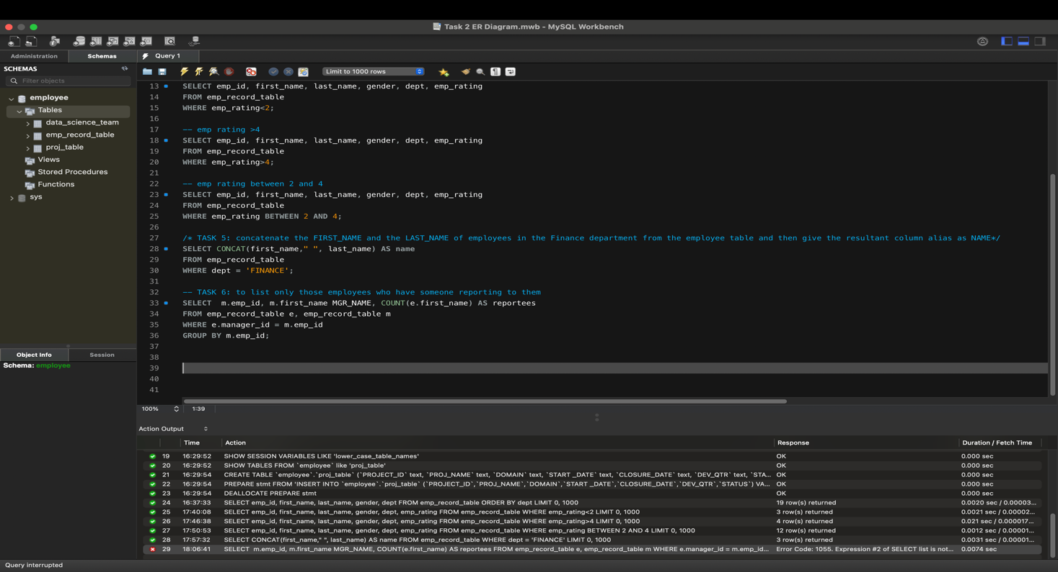

To clear this error, enter the following command:

SELECT @@sql_mode;

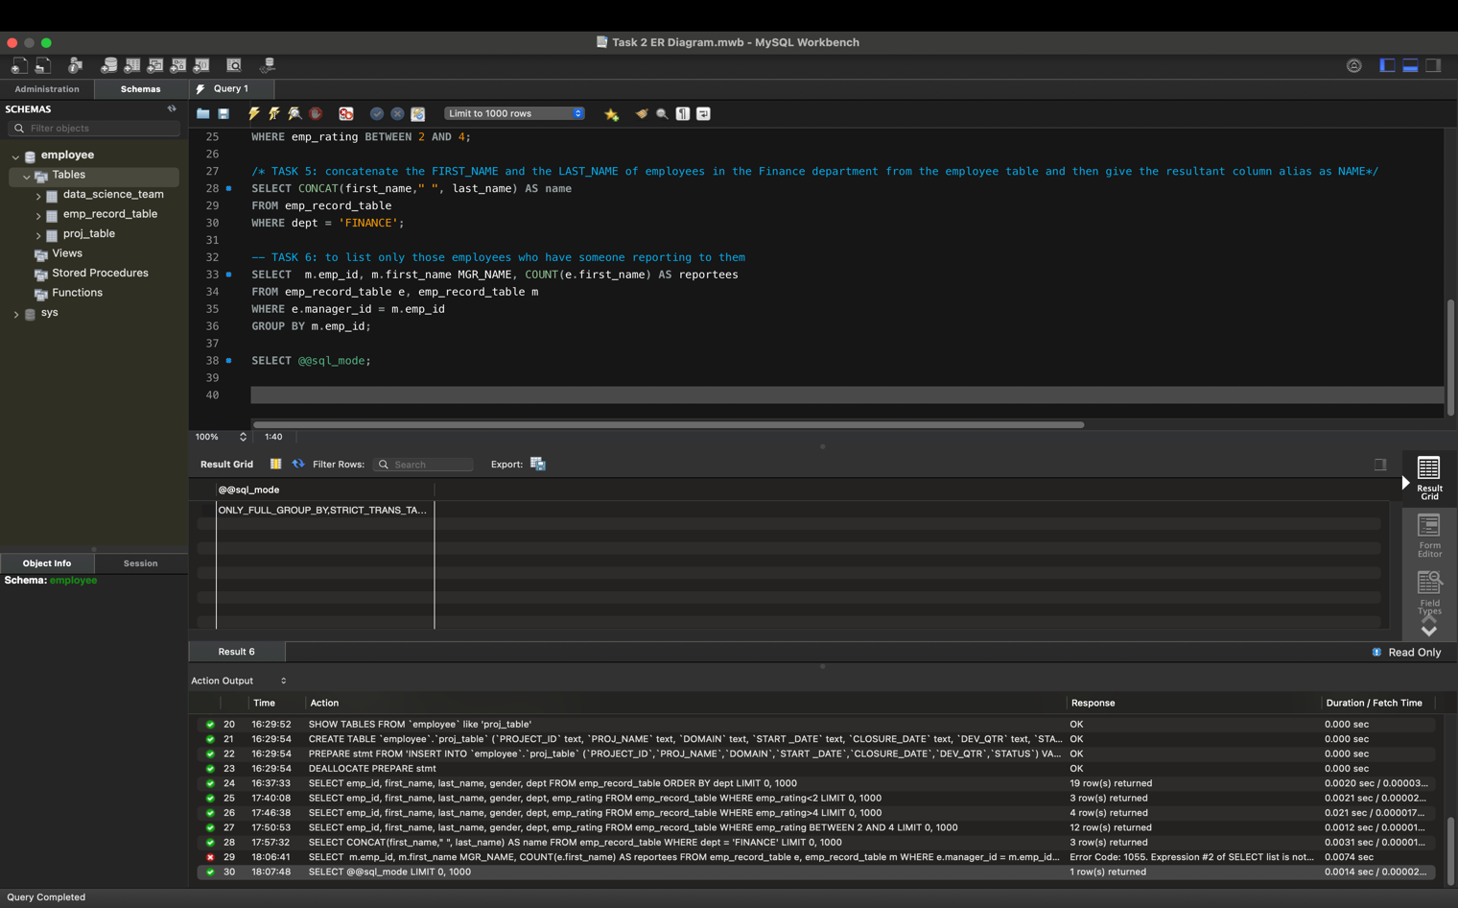

SET @@sql_mode = SYS.LIST_DROP(@@sql_mode, 'ONLY_FULL_GROUP_BY');

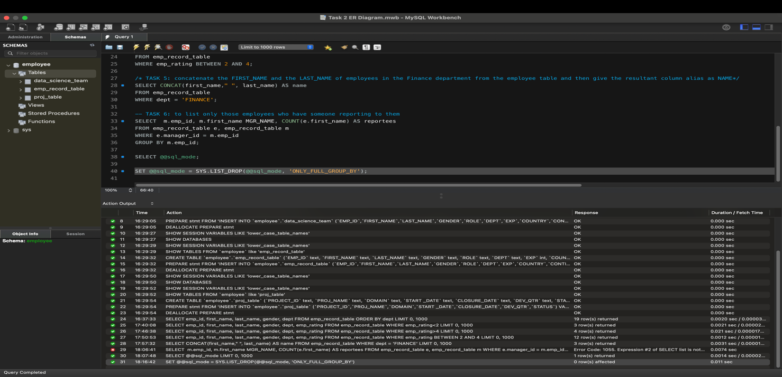

SELECT @@sql_mode;

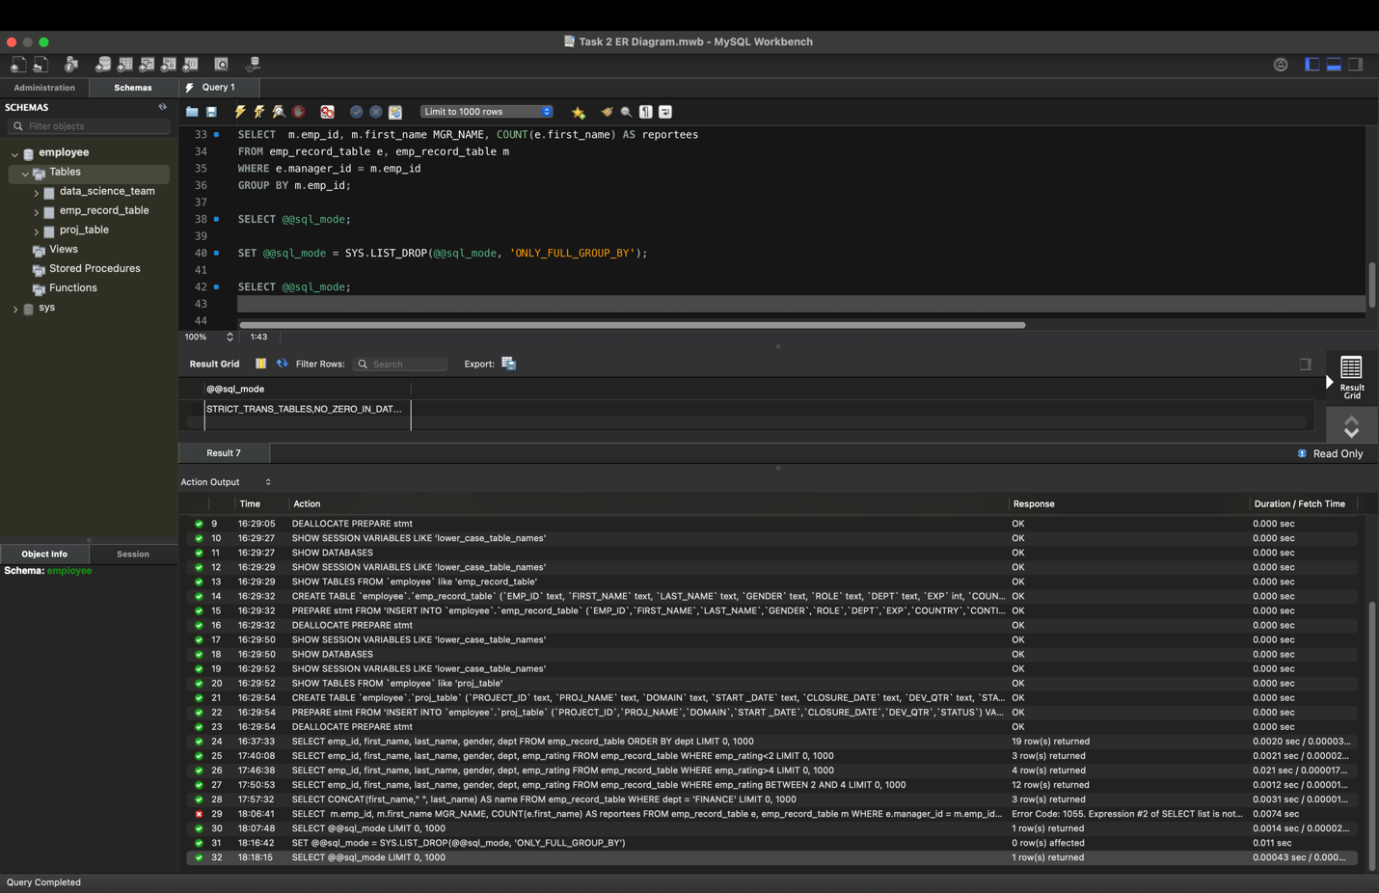

SELECT m.emp_id, m.first_name MGR_NAME, COUNT(e.first_name) AS reportees

FROM emp_record_table e, emp_record_table m

WHERE e.manager_id = m.emp_id

GROUP BY m.emp_id;

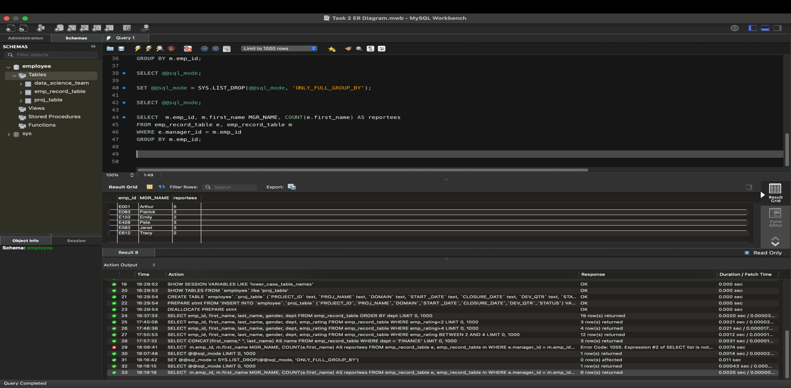

**Task 7:** Write a query to list down all the employees from the healthcare and finance departments using union. Take data from the employee record table.

Code:

-- TASK 7:list down all the employees from the healthcare andfinance departments using union

SELECT emp_id, first_name, dept FROM emp_record_table WHERE dept = 'HEALTHCARE'

UNION

SELECT emp_id, first_name, dept FROM emp_record_table WHERE dept = 'FINANCE';

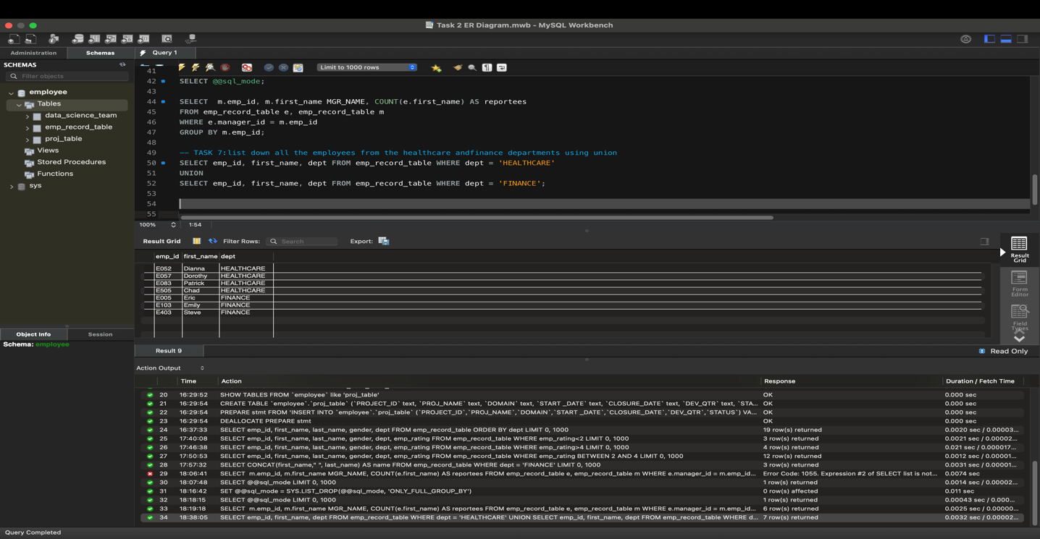

Task 8: Write a query to list down employee details such as EMP_ID, FIRST_NAME, LAST_NAME, ROLE, DEPARTMENT, and EMP_RATING grouped by dept. Also include the respective employee rating along with the max emp rating for the department.

Code:

/*TASK 8: List down employee details such as EMP_ID,FIRST_NAME, LAST_NAME, ROLE, DEPARTMENT, and EMP_RATING grouped by dept.

Also include the respective employee rating alongwith the max emp rating for the department*/

SELECT emp_id, FIRST_NAME, LAST_NAME, ROLE, DEPT, EMP_RATING,

MAX(EMP_RATING) OVER (PARTITION BY DEPT) AS MAX_EMP_RATING

FROM emp_record_table;

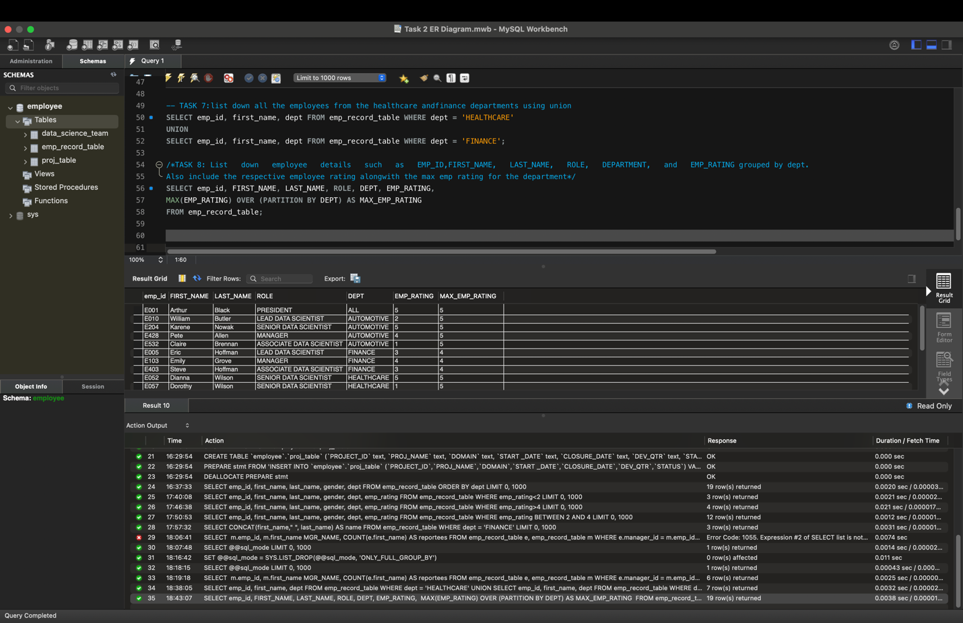

**Task 9:** Write a query to calculate the minimum and the maximum salary of the employees in each role. Take data from the employee record table.

Code:

-- TASK 9:To Calculate the minimum and the maximum salary ofthe employees in each role

SELECT emp_id, FIRST_NAME, LAST_NAME, ROLE, DEPT, salary,

MIN(salary) OVER (PARTITION BY role) AS MIN_salary,

MAX(salary) OVER (PARTITION BY role) AS MAX_salary

FROM emp_record_table;

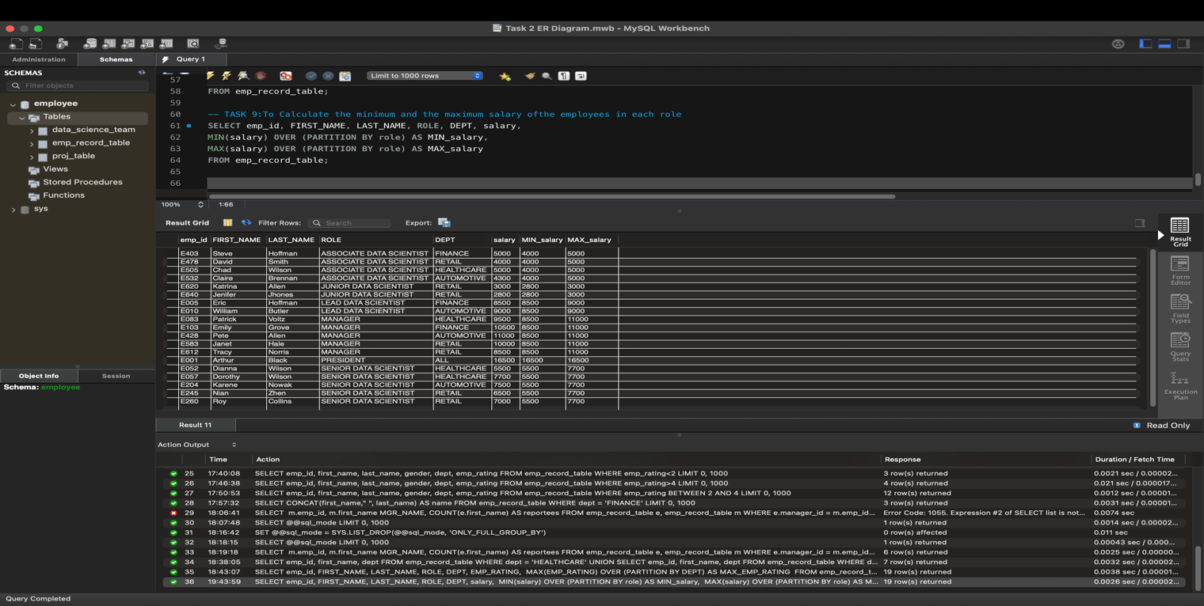

**Task 10:** Write a query to assign ranks to each employee based on their experience. Take data from the employee record table.

Code:

-- TASK 10: Assign ranks to each employee based on their experience

SELECT emp_id, FIRST_NAME, LAST_NAME, ROLE, DEPT, exp,

RANK() OVER(ORDER BY exp DESC) emp_exp_rank,

DENSE_RANK() OVER(ORDER BY exp DESC) emp_exp_dense_rank

FROM emp_record_table;

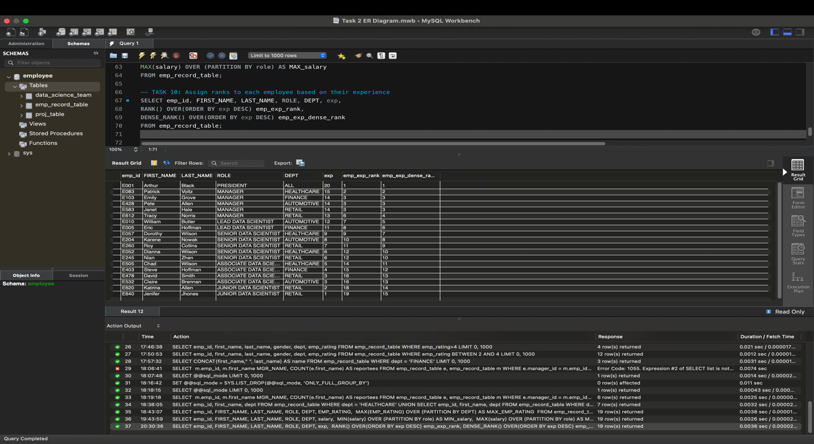

**Task 11:** Write a query to create a view that displays employees in various countries whose salary is more than six thousand**.** Take data from the employee record table.

Code:

-- TASK 11: Create a view that displays employees in various countries whose salary is more than six thousand

CREATE VIEW v_emp AS

SELECT * FROM emp_record_table WHERE salary > 6000;

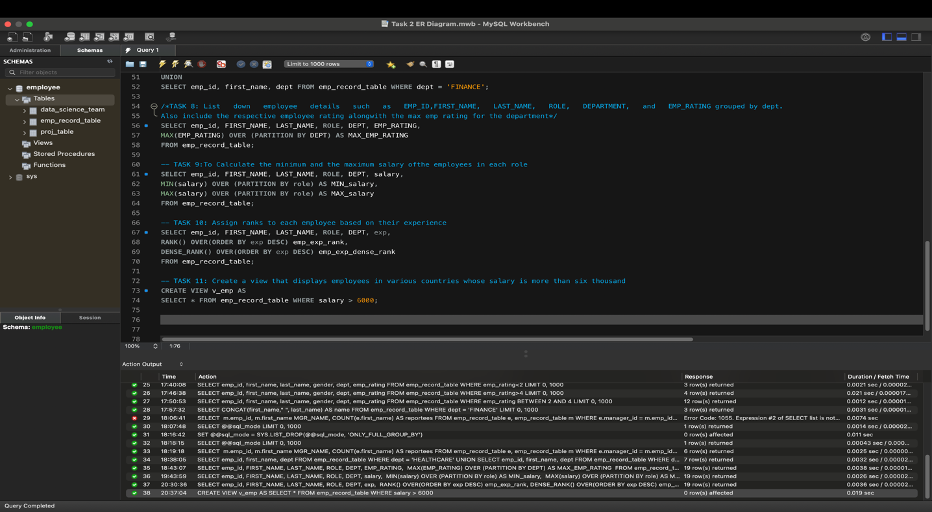

SELECT * FROM v_emp;

Result:

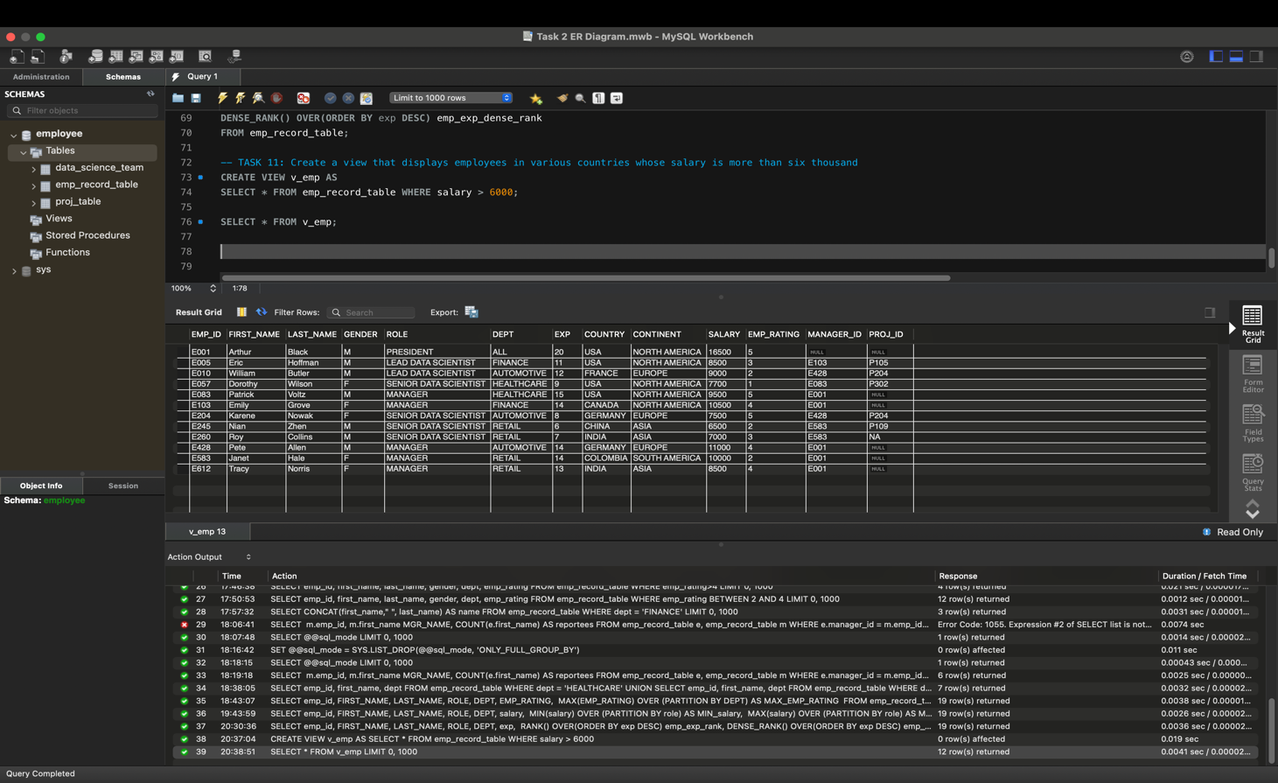

**Task 12:** Write a nested query to find employees with experience of more than ten years. Take data from the employee record table.

**Code:**

-- TASK 12: Nested query to find employees with experience of morethan ten years

SELECT e.emp_id, e.first_name, e.exp

FROM emp_record_table e

WHERE e.emp_id IN

(SELECT s.emp_id

FROM emp_record_table s

WHERE s.exp > 10);

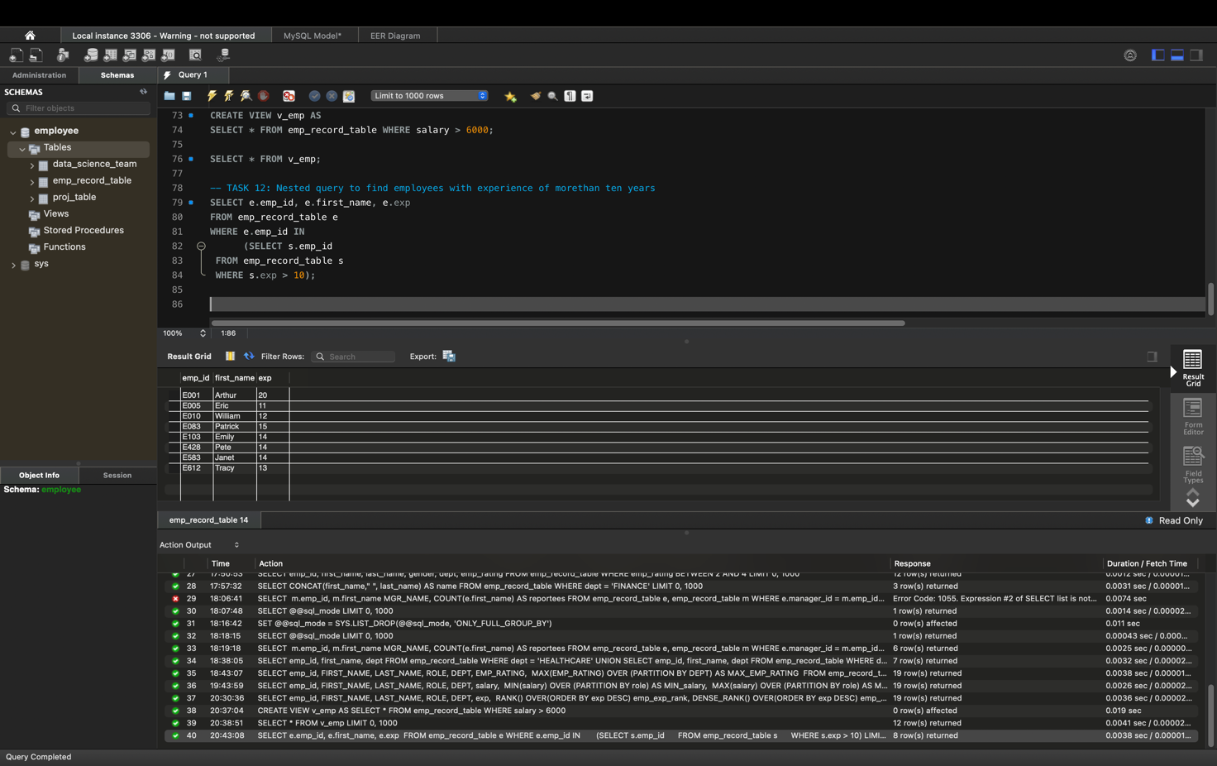

**Task 13:** Write a query to create a stored procedure to retrieve the details of the employees whose experience is more than three years. Take data from the employee record table.

Code:

-- TASK 13: Create a stored procedure to retrieve the details of the employees whose experience is more than three years

DELIMITER //

CREATE PROCEDURE sp_emp()

BEGIN

SELECT *

FROM emp_record_table

WHERE exp > 3;

END;

//DELIMITER ;

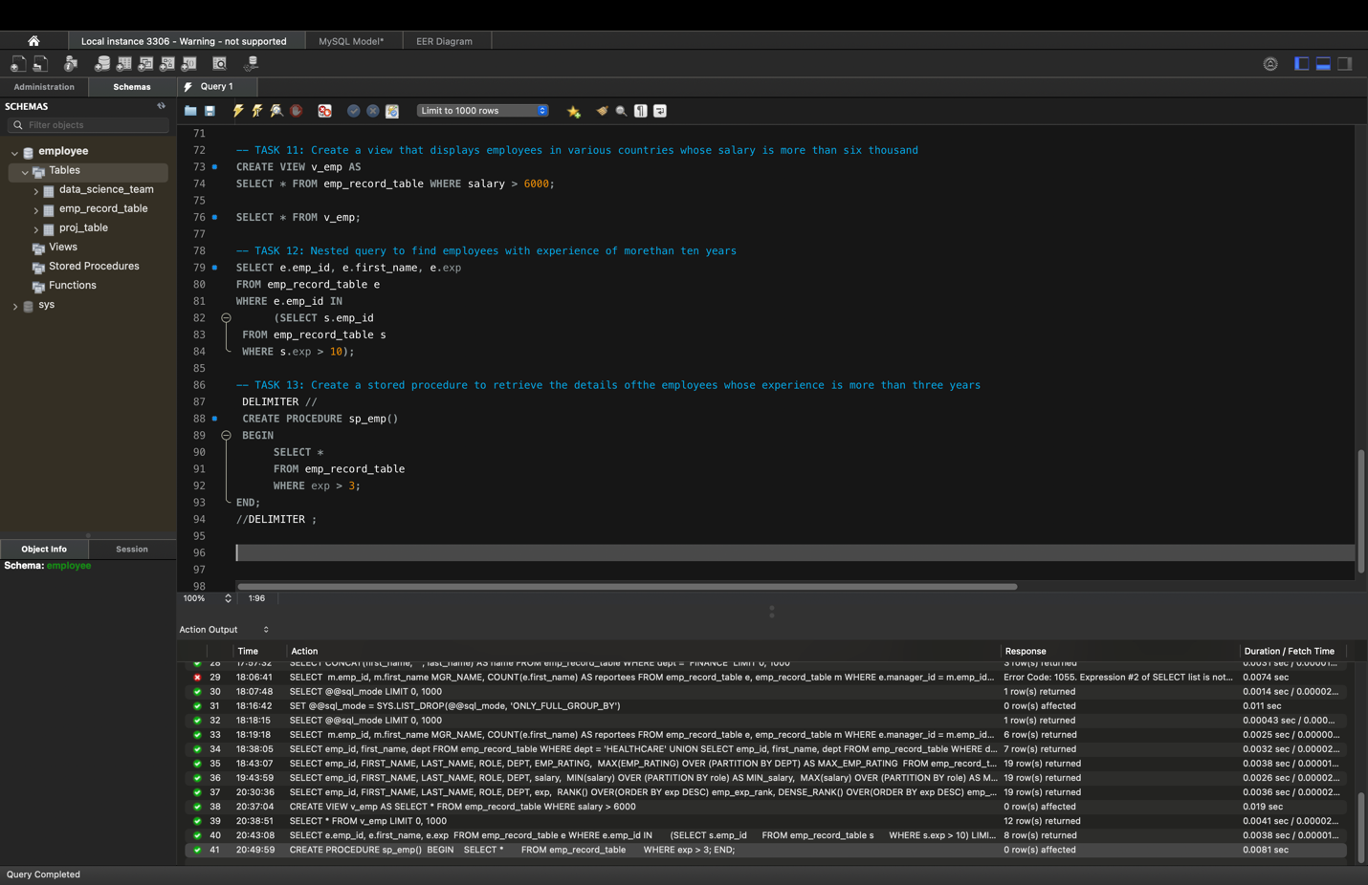

CALL sp_emp()

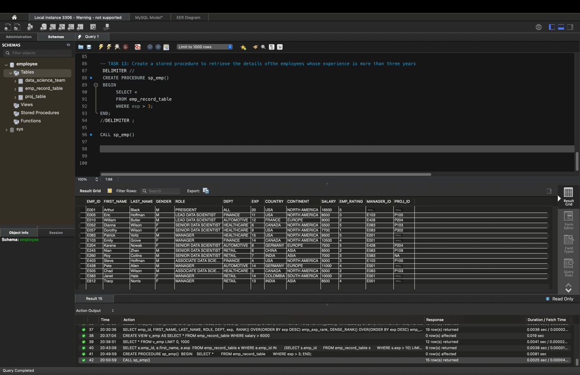

**Task 14:** Write a query using stored functions in the project table to check whether the job profile assigned to each employee in the data science team matches the organization’s set standard.

The standard being:

For an employee with experience less than or equal to 2 years assign 'JUNIOR DATA SCIENTIST',

For an employee with the experience of 2 to 5 years assign 'ASSOCIATE DATA SCIENTIST',

For an employee with the experience of 5 to 10 years assign 'SENIOR DATA SCIENTIST',

For an employee with the experience of 10 to 12 years assign 'LEAD DATA SCIENTIST',

For an employee with the experience of 12 to 16 years assign 'MANAGER'.

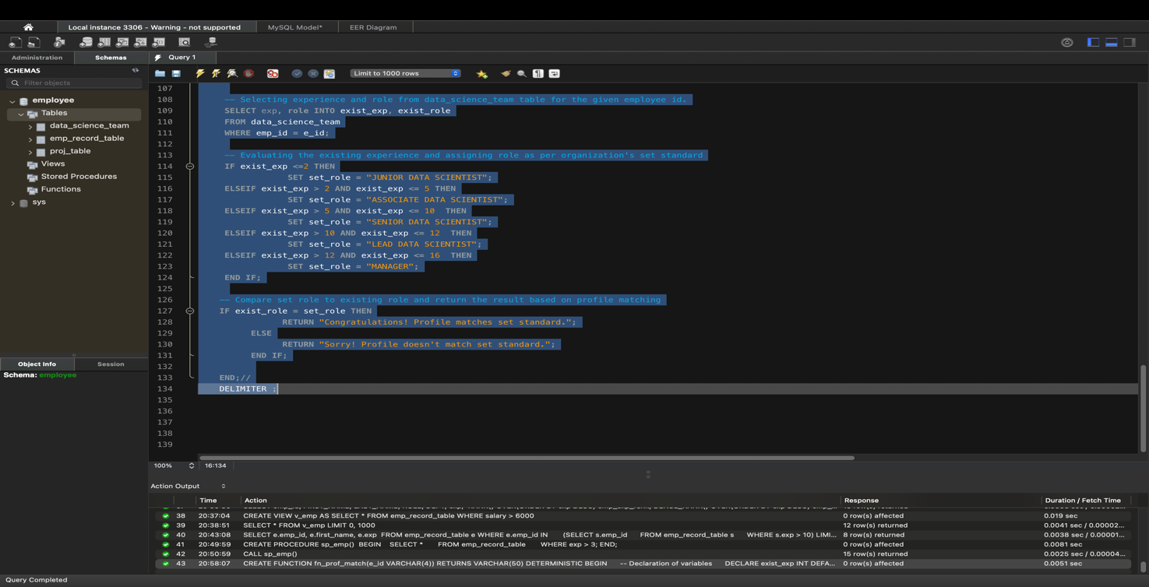

SHOW FUNCTION STATUS WHERE db = 'employee';

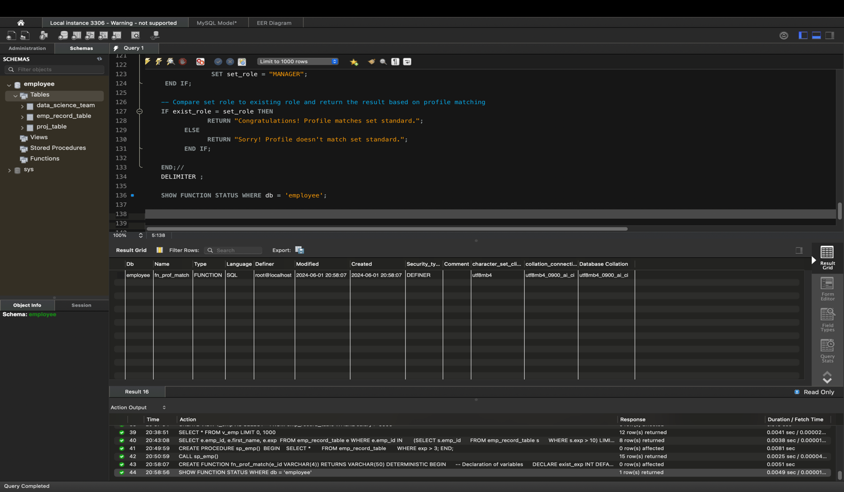

SELECT fn_prof_match('E005');

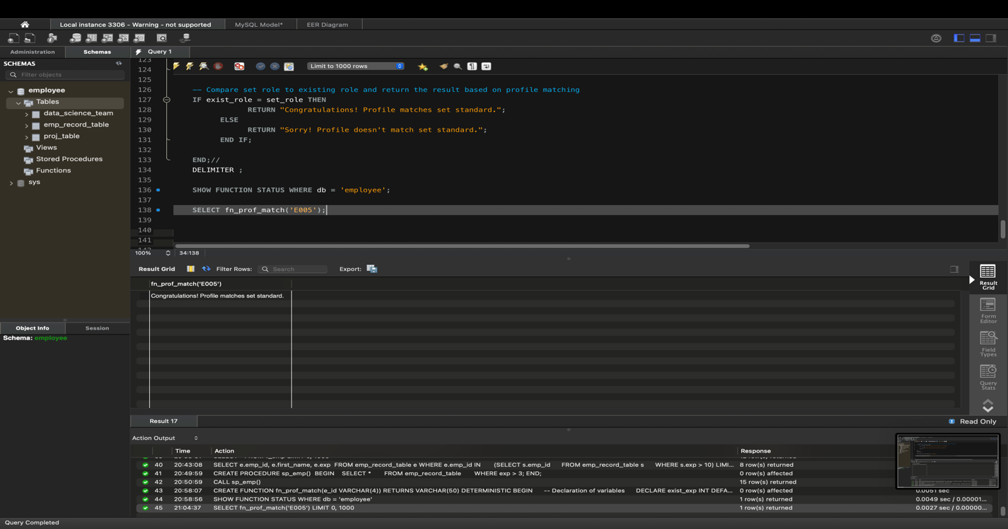

SELECT fn_prof_match('E007');

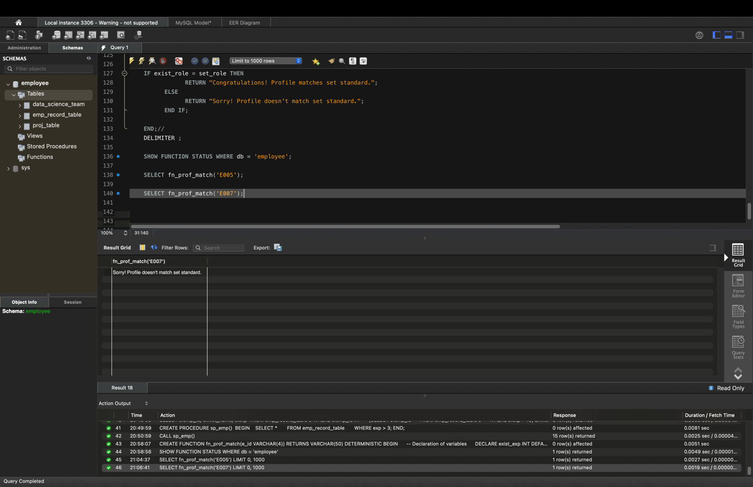

**Task 15 :** Create an index to improve the cost and performance of the query to find the employee whose FIRST_NAME is ‘Eric’ in the employee table after checking the execution plan.

Code:

/* TASK 15: Write a query to create an index to improve the cost and performance of the query to find the employee

whose FIRST_NAME is ‘Eric’ in the employee table after checking the execution plan*/

-- Before creating an Index:

SELECT * FROM emp_record_table WHERE first_name = 'Eric';

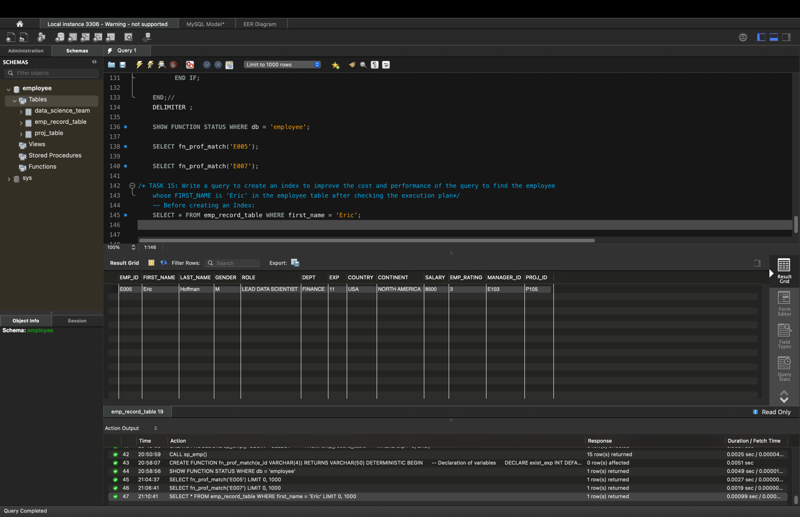

-- Creating index:

CREATE INDEX id_emp_fn ON emp_record_table(first_name(7));

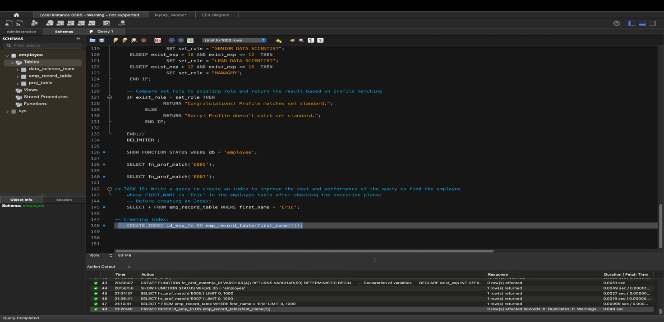

-- After creating an Index:

SELECT * FROM emp_record_table WHERE first_name = 'Eric';

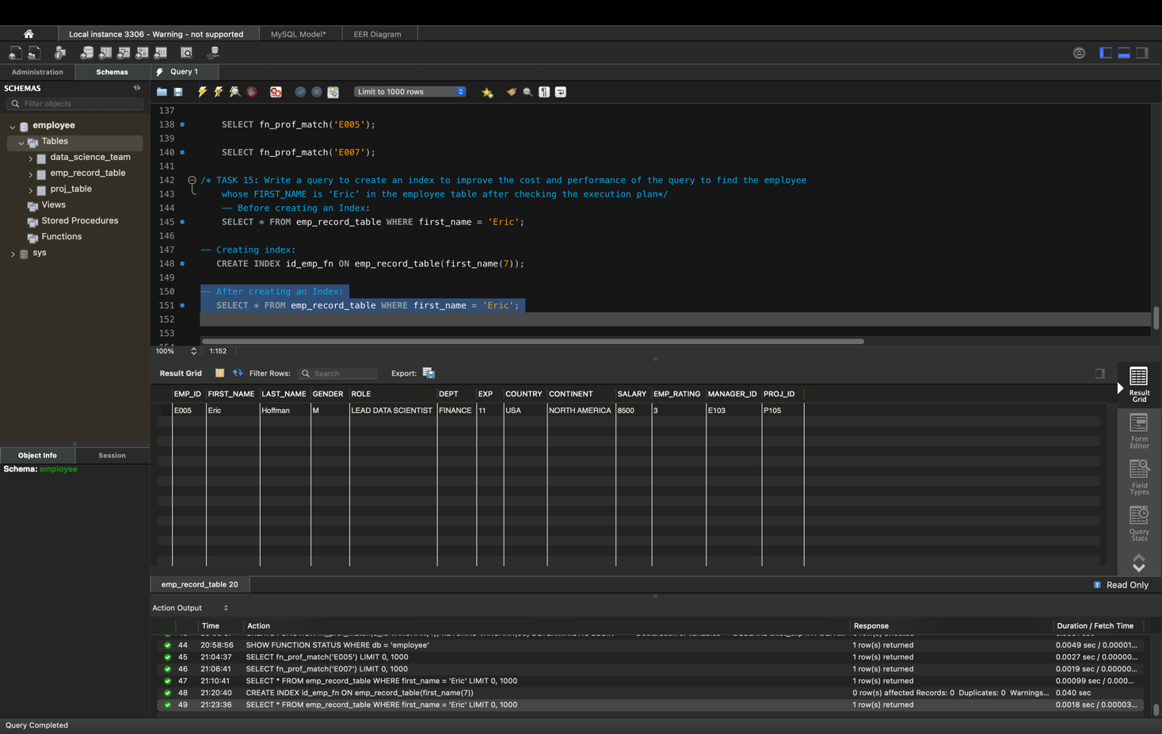

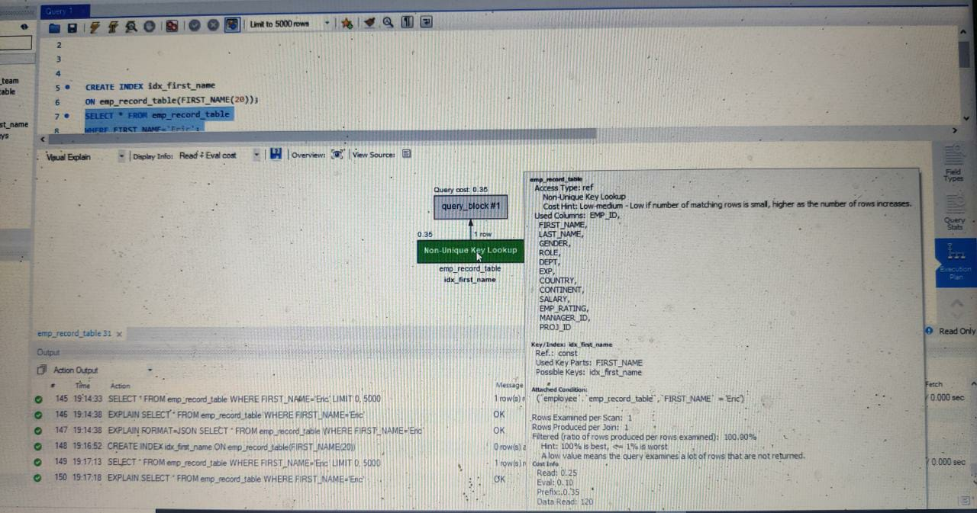

**Task 16:** Write a query to calculate the bonus for all the employees, based on their ratings and salaries (Use the formula: 5% of salary * employee rating).

Code :

/* TASK 16: Write a query to calculate the bonus for all the employees, based on

their ratings and salaries (Use the formula: 5% of salary * employee rating) */

SELECT emp_id, first_name, salary, emp_rating, (0.05*salary*emp_rating) AS bonus

FROM emp_record_table;

Result:

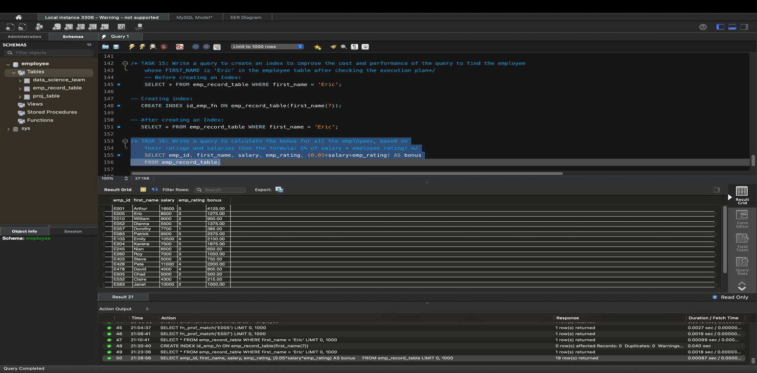

**Task 17:** Write a query to calculate the average salary distribution based on the continent and country. Take data from the employee record table.

**Code:**

/* TASK 17: Write a query to calculate the average salary distribution based on the continent and country.

Take data from the employee record table */

SELECT emp_id, FIRST_NAME, salary, country, continent,

AVG(salary) OVER(PARTITION BY country) avg_country_sal,

AVG(salary) OVER(PARTITION BY continent) avg_continent_sal

FROM emp_record_table;

Result:

